**ST.XAVIER’S COLLEGE**

MAITIGHAR, KATHMANDU



Computer Graphics

Assignment #1

Submitted By:

Aabhash Dhakal

013BSCCSIT001

2nd year/ 4th semester

Submitted to:

|  |  |
| --- | --- |
| Er. Anil K. Sah  Lecturer  Department of Computer Science |  |

**STATEMENT**

Write a program to draw a checkbox.

­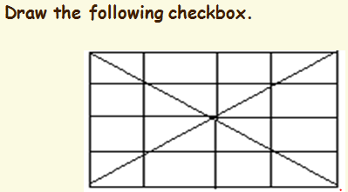

**SOURCE CODE**

//---------------------------------------------------------------------------

#include <vcl\vcl.h>

#pragma hdrstop

#include "Checkbox1.h"

//---------------------------------------------------------------------------

#pragma resource "*.dfm"

TForm1 *Form1;

//---------------------------------------------------------------------------

__fastcall TForm1::TForm1(TComponent* Owner)

: TForm(Owner)

{

}

//---------------------------------------------------------------------------

void __fastcall TForm1::Button1Click(TObject *Sender)

{

Form1->Canvas->MoveTo(10,10);

Form1->Canvas->LineTo(200,200);

Form1->Canvas->MoveTo(10,10);

Form1->Canvas->LineTo(10,200);

Form1->Canvas->MoveTo(10,10);

Form1->Canvas->LineTo(200,10);

Form1->Canvas->MoveTo(10,200);

Form1->Canvas->LineTo(200,200);

Form1->Canvas->MoveTo(10,200);

Form1->Canvas->LineTo(200,10);

Form1->Canvas->MoveTo(200,10);

Form1->Canvas->LineTo(200,200);

Form1->Canvas->MoveTo(55,10);

Form1->Canvas->LineTo(55,200);

Form1->Canvas->MoveTo(105,10);

Form1->Canvas->LineTo(105,200);

Form1->Canvas->MoveTo(155,10);

Form1->Canvas->LineTo(155,200);

Form1->Canvas->MoveTo(10,55);

Form1->Canvas->LineTo(200,55);

Form1->Canvas->MoveTo(10,105);

Form1->Canvas->LineTo(200,105);

Form1->Canvas->MoveTo(10,155);

Form1->Canvas->LineTo(200,155);

}

//---------------------------------------------------------------------------

**OUTPUT SCREEN**

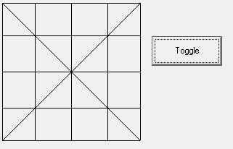

**CONCLUSION**

Hence, a checkbox was drawn in C++ builder.